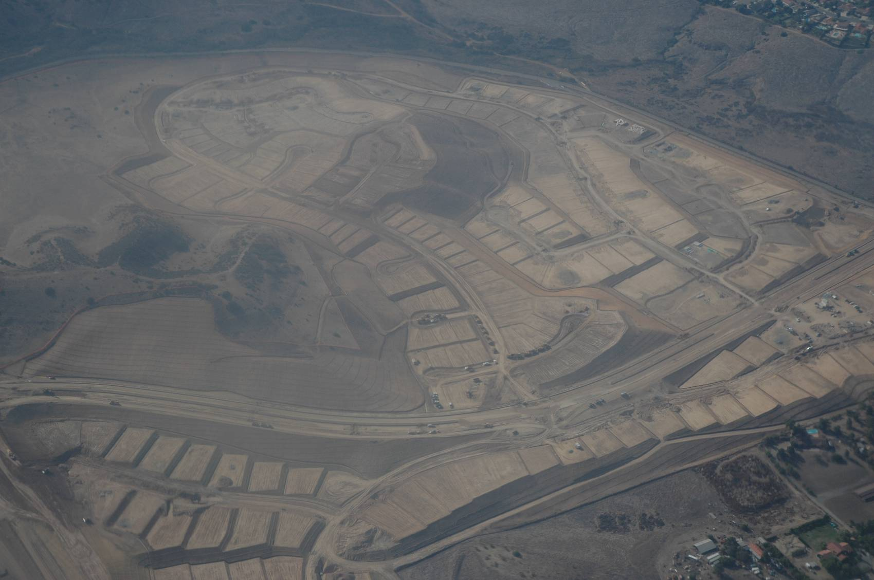

Producing New Community, or undermining it? Subdivision grading, road layout, and site preparations for a new suburban community north of San Diego, California, December 2005 (Elvin Wyly).

Community and Connection in Suburbia
Urban Studies 200, Cities
Elvin Wyly

Can “suburbia” ever get any respect?

Should it?

Suburbs are comparatively new settlements adjacent to, subordinate to, and functionally dependent upon, older, higher-density urban places. Suburbs are nothing new: many ancient cities were surrounded by settlements that were reliant on the central core, and that developed at comparatively lower densities. Suburbanization came to take on a new character after the Industrial Revolution, however, as accelerating capitalist growth produced vivid and terrifying inequalities of wealth and power in rapidly-growing cities. Suburbs came to be seen as spaces of refuge from an increasingly threatening city of industrial pollution, over-crowded housing, and perpetual class conflict. Those who had the means to escape the exploding industrial metropolis did so, as fast as they could -- even if it required spending more time traveling from a suburban home to work in the city. Suburbia came to be understood as an escape to safety and spacious living -- even if suburbs still remained subordinate to the dominant economic power of the city’s factories, offices, and other workplaces.

This ambivalent view of suburbia was highlighted most clearly in a massive outmigration of households out of the densely-packed cores of cities in Canada and the United States after the end of the Second World War in 1945. Post-World War II North American suburbanization came to dominate urban theory, and for better or worse, the varied trajectories of suburbanization around the world today are often compared to the “reference point” of the North American experiences. It is thus worth considering the reactions to this social and spatial form that has come to be paradigmatic. First, we’ll consider the backlash against suburbia. Then we’ll consider the contemporary diversity of suburbs, before turning our attention to the way commerce and advertising are being used to understand the spatially expansive communities of suburbia. Finally, we’ll take a look at how suburban communities and ways of life are shaped by transport technologies -- especially the automobile -- and how despite the challenges, suburban community ties can and do remain strong in many places.

The Backlash Against Suburbia

The explosion of suburban growth in Canada and the United States was more rapid than anything ever seen before. Millions of households left old city apartments for new homes in the suburbs, which they usually bought with subsidized mortgage credit at the same time they purchased a new automobile. Almost immediately, however, social scientists began to question this huge migration to the exploding edge of the metropolis. Lewis Mumford offered eloquent but harsh historical condemnation:

“From the thirteenth century on, the dread of plague prompted a periodic exodus from the city; and in that sense, one may say that the modern suburb began as a sort of rural isolation ward.”

William H. Whyte, author of the best-selling book, The Organization Man, was similarly critical:

“To find where the mobility of organization life is leading, the new package suburbia may be the best place of all to look. For they are not merely great conglomerations of mass housing. They are a new social institution, and while the variations in them are many, wherever one goes -- the courts of Park Forest, the patios of Park Merced in San Francisco, Philadelphia’s Drexelbrook, the new Levittown, Pennsylvania -- there is an unmistakable similarity in the way of life.”

Although Whyte’s study was much more careful than most popular and press accounts of the time, his interpretation of suburban life was harsh indeed, such as the judgment that

“As far as social values are concerned, suburbia is the ultimate expression of the interchangeability so sought by organization.”

Suburbia was attacked as a barren, uniform landscape of interchangeable conformers who had traded the challenges, risks, and opportunities of the diverse city for the false promise of security in the house with its own front and back yards. Much of the social critique of suburbia portrayed the specter of individuality destroyed by suburban conformity, and the parallels drawn by John Keats -- who wrote of a Mary Drone who “dwelt in a vast communistic barracks” -- were deeply ironic. William J. Levitt, the developer who pioneered the application of assembly-line industrial practices to housebuilding, is often best remembered for his quote that “No man who owns his own house and lot can be a Communist. He has too much to do.”
Suburbia was attacked as a barren, uniform landscape of interchangeable conformers who had traded the challenges and risks of the diverse city for the false promise of security in the house with its own front and back yard.

Harsh criticism of suburbia persists today. “The transformation of Canada into a suburban nation eventually led to a suppression of diversity,” writes Richard Harris, a pre-eminent analyst of Canada’s urban and suburban histories.

“By 1960 people spoke freely of ‘the Canadian suburb.’ Suburbs were being created in standard ways, and those who bought into them lived a fundamentally similar way of life. ... in this book I tell a story of creeping conformity, not only of the suburbs but also of certain aspects of Canadian society.”

And yet any careful consideration exposes the myth of a unitary suburbia, and raises fundamental questions about a presumed ‘suburban way of life.’ Harris takes as the point of departure for his book the pronounced diversity of suburban forms apparent in the early twentieth century in Canada -- both in terms of the ways they were built, and the circumstances of people who lived in suburban communities. Due to poor planning and other failures, this diversity was gradually supplanted by a “creeping conformity.” But conformity -- and indeed all sorts of other problems blamed on suburbia -- was not inevitable in the past, and it is not inevitable today. Barbara Phillips points out that

“When the dust started settling on the newly paved roads of tract homes, social scientists began to paint a more complex portrait of suburban life. ... By the 1960s, researchers dropped the label ‘suburbia.’ It was, they inferred, a myth. Suburbs do not look alike, nor do their inhabitants share a lifestyle.”

Similarly, the historian Kenneth T. Jackson, in his influential Crabgrass Frontier, traces a long and winding path of growth and change that has culminated in the suburban landscapes we see today. It did not have to work out exactly as it did, and in some times and places we can find remarkable exceptions to the stereotypical histories told in those early attacks on suburbia.

“Some might be tempted to classify Vancouver’s tortuously sophisticated anti-Surrey bias in the same category as Manhattan’s disdain for the ‘bridge-and-tunnel crowd,’ but the analogy isn’t quite apt. In Manhattan, a genuine superiority complex is in play, making the contempt for peripheral suburbanites (in this case sub-urban, as in beneath city-dwellers) casual and off-handed. In provincial Vancouver, aspirant middle-class types desperately repeating the mantra world-class city (that phrase being the closest thing to a ritual prayer we have out here) are so desperate not to be confused with the rubes east of Metrotown Mall that they lash out against Surrey with both vigour and fear. Not as important as Toronto, not as well-dressed as Montreal, not as rich as Calgary, Vancouver shits on Surrey like a kid with a lazy eye draws a bully’s attention to the fat kid.” Charles Demers (2009). Vancouver Special. Vancouver: Arsenal Pulp Press, pp. 15-16.
Herbert Gans, a legendary sociologist and urban planner, wrote a highly influential study of Levittown, New Jersey, in which he used participant-observation methods to describe life in the first two years after the subdivision was built. The prevailing climate of hostility against suburbs led Gans to begin his preface this way:

“This book is about a much maligned part of America, suburbia, and reports on a study conducted by an equally maligned method, sociology. The postwar suburban developments...have been blamed for many of the country’s alleged and real ills, from destroying its farmland to emasculating its husbands.”

Gans offered a rigorous, balanced, and nuanced account of the Levittowners, and his richly-documented book cast doubt on the widespread assumption that suburbia was destroying those who moved there.

“People’s lives are changed somewhat by the move to suburbia, but their basic ways remain the same ... many of the changes that do take place were desired by the move. Because the suburb makes them possible, morale goes up, boredom and loneliness are reduced, family life becomes temporarily more cohesive, social and organizational activities multiply, and spare-time pursuits now concentrate on the house and yard.”

A Critical yet Constructive Approach

Suburban development has a wide range of negative consequences. Sometimes it allows for dominant groups to withdraw from the diversity of the city, and to form their own exclusive political space while abandoning any broader responsibilities to society. In other cases, suburbanites themselves are the marginalized ones -- the extremely poor residents of informal settlements on the outskirts of Latin American cities, or in the large social housing estates on the fringe of expensive European cities. Suburban development has often involved large, hidden subsidies -- such as tax policies favoring the purchase of new homes, or the huge public expenditures required to build and maintain vast street and highway networks. The typical housing of the typical suburb -- the detached, single-family home on its own private lot -- requires an enormous amount of labor to maintain and keep clean; suburbs thus tend to reinforce traditional gender roles between men and women, and often make it extremely difficult for women to balance family work with career goals in the workforce. Suburban development often produces landscapes that are repetitive or confusing to navigate, or that require the use of the automobile to do almost anything outside the home.
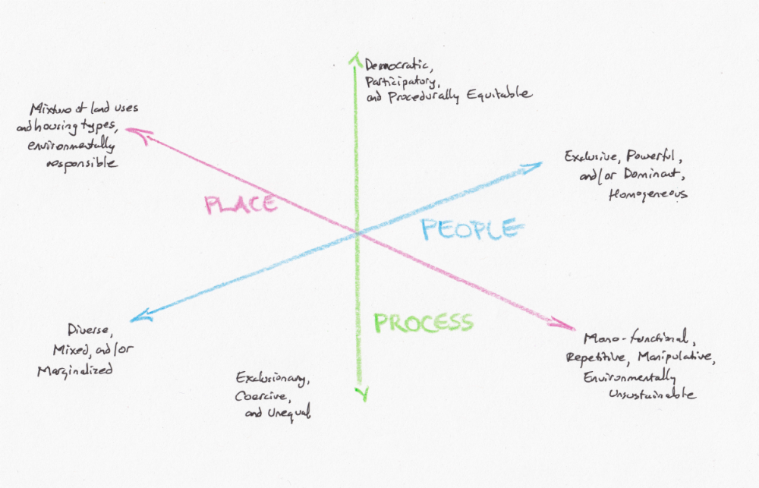
Suburbia in Three Dimensions. Snap judgments on whether suburbia is good or bad can be dangerous. In assessing the consequences of suburban community, it is helpful to use three-dimensional axes to distinguish the processes creating suburban landscapes, from the characteristics and motivations of people who live in suburbs, and the physical and functional characteristics of suburban places.
But we must recognize these problems carefully, while keeping in mind the extraordinary diversity of contemporary suburban experiences, and the plurality of interpretations of suburbia. Hard as it might be, we must avoid the polemical attacks on suburbia that have been popularized in recent years by authors like James Howard Kunstler, author of books like “The Geography of Nowhere,” who has attacked suburbanization for producing “places not worth caring about.” This is harsh, and it is also quite dangerous. When we attack the building styles or street layouts found in suburbia, for example, are we also criticizing the intelligence of people who have chosen to live there?
Diverse Interpretations of Suburbia

Suburbs can be interpreted as
1. Natural ecological extensions of organic, evolutionary urban expansion.

2. Escapism from the problems of industrial cities.

3. Economic policy tools that boost consumption and macroeconomic demand.

4. Investment and speculation opportunities for landowners, developers, and financial interests.

5. Social engineering programs to rescue or reform the poor, or to recapture a lost traditional way of life.

6. Rational locations for cost-conscious firms and/or households.

7. Maps of consumer preferences among households who want new homes, abundant space, and certain public services.

8. Socio-political strategies to separate from a nearby metropolis while still enjoying the economic benefits of proximity to the city.

9. Asylums, or defensive strategies driven by a far of “others,” decline, crime, and threats to property values.

10. Rural nostalgia, and a desire to return to the countryside while still relying on the economy of the city.

Source: Adapted from Larry S. Bourne (1996). “Reinventing the Suburbs: Old Myths and New Realities.” Progress in Planning 46(3), 163-184.

A critical, constructive approach requires separating aspects of the processes that create suburbia, the decisions and constraints of people who live there, and the characteristics of the places.

Being critical does not require being mean, or being careless. We do need to offer a critical perspective on suburban growth and development, because this is now the dominant way new urban spaces are produced everywhere around the world. But a constructive critical approach requires that we carefully separate different facets of the suburban phenomena: we need to think carefully about variations in the processes that produce suburban landscapes, the choices and motivations of people who choose (or are forced to) live in suburbia, and the physical and functional characteristics of suburban places.

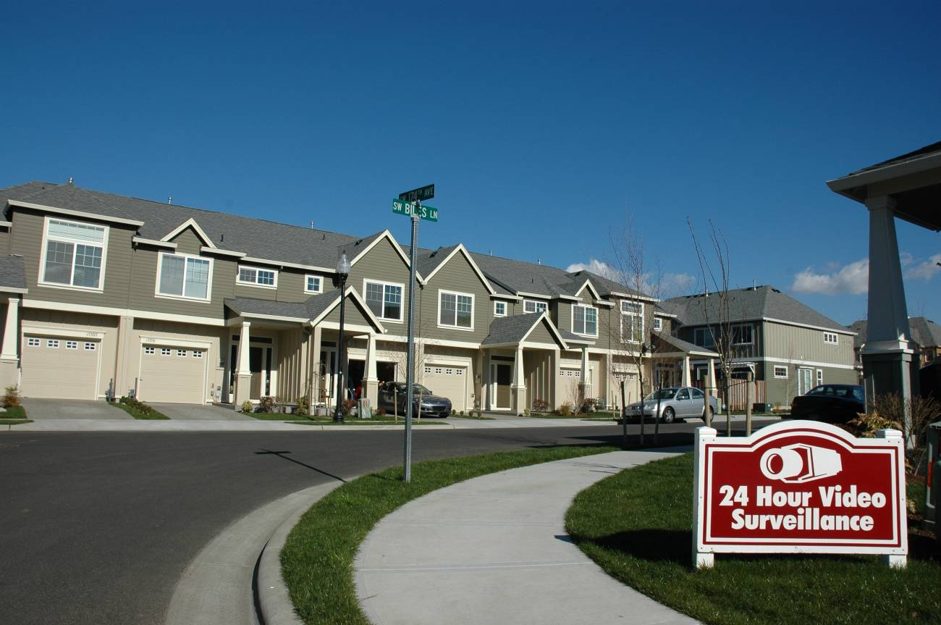
Surveillant Suburb. Beaverton, Oregon, just west of Portland, February 2006 (Elvin Wyly). In suburbs with insufficient wealth to create full-fledged gated communities, inexpensive video technology is often used to warn outsiders.

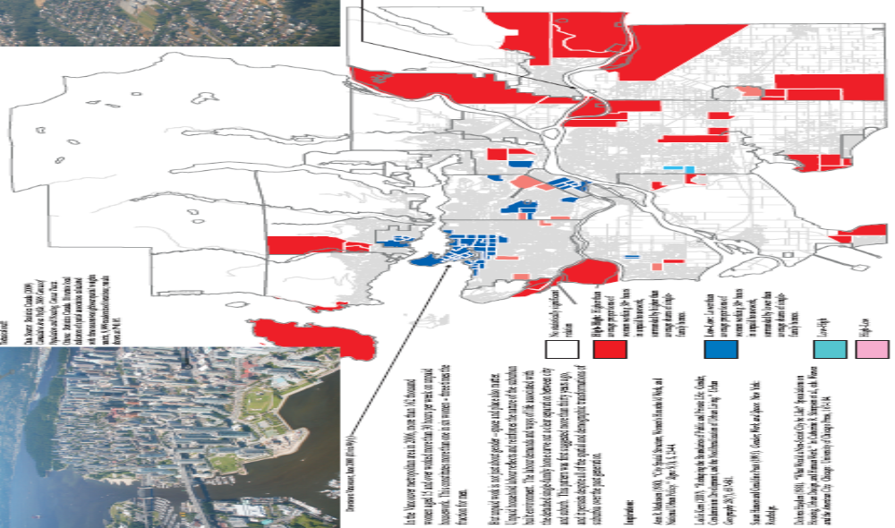

Gender and Suburbia. Social scientists have known for many years that variations in built form -- the way homes and workplaces are laid out in various parts of cities -- can reflect and reinforce gender relations. The detached, single-family house in the suburbs typically requires a great deal of labor to clean and maintain. In the Vancouver region, one out of six women -- 162 thousand -- works more than thirty hours per week on unpaid household labor; this is three times the fraction for men. Areas shaded red are spatial clusters with higher-than average shares of women working more than thirty hours per week on unpaid household labor; areas shaded blue are spatial clusters with lower-than-average shares. Map by Elvin Wyly, using data from the 2006 Census of Canada. See Dolores Hayden (1981). “What Would a Non-Sexist City be Like? Speculations on Housing, Urban Design, and Human Work.” In Catherine M. Stimpson et al., eds., Women and the American City. Chicago: University of Chicago Press, 167-184. See also Leslie Kern (2007). “Reshaping the Boundaries of Public and Private Life: Gender, Condominium Development, and the Neoliberalization of Urban Living.” Urban Geography 28(7), 657-681. For the full graphic, see http://www.geog.ubc.ca/~ewyly/transfer/sample.pdf

No Longer Subordinate or Subsidiary

The continued outward expansion of rings of suburbs, and the intensification of new kinds of non-residential development, rendered the stereotypical image of isolated bedroom communities obsolete. North American suburbs began to evolve in ways that questioned their presumed subordinate status to a nearby ‘central city.’ The United States became a suburban nation according to the statistical criteria as early as 1980, and since then the suburban dominance in numerical terms has only strengthened. Moreover, suburbanites seem to be living more and more of their lives in suburbia -- either their own neighborhood, or on the road between their home and other suburban communities. Gans’ book was only the first in a long line of studies that sought to document the increasing diversity of suburbs, and in recent years the pace of social and spatial transformation spawned a cottage industry of new descriptive terms: bourgeois utopias, technoburbs, cyburbia, and, most famously, ‘edge cities.’ Joel Garreau, a writer who now spans the professions of journalist and university professor, is best known for his book Edge City: Life on the New Frontier, in which he argued that suburbs are evolving into fully autonomous communities with social and cultural lives that rely less and less on the older ‘central city’ of the industrial age. For Garreau, the city of the future is the edge city – a place that is on the edge of the old urban settlements built in previous generations, but now very much at the center of the lives and cultures of millions of people who live in them, and who longer feel a strong connection to the old ‘central city’.
Joel Garreau’s concept of the “edge city” announced the arrival of a new age, in which suburbs are fully autonomous communities that have no need for the older “central city” nearby.

The Edge City Age

Garreau’s Edge City turned out to be a powerful and influential way of summarizing the enormous changes afoot across the North American landscape. The term made its way into countless academic and policy debates, and also began to pervade popular discussions. Tom Wolfe captured the spirit of edge city through the character of Charlie Croker, a powerful developer, in his novel A Man in Full:

“He looked away from the buildings and out over the ocean of trees. Since Atlanta was not a port city and was, in fact, far inland, the trees stretched on in every direction. They were Atlanta’s greatest natural resource, those trees were. People loved to live beneath them. Fewer than 400,000 people lived within the Atlanta city limits, and almost three quarters of them were black; if anything, over the past decade Atlanta’s population had declined slightly. But for the past thirty years all sorts of people, most of them white, had been moving in beneath those trees, into all those delightful, leafy, rolling, rural communities that surrounded the city proper. By the hundreds of thousands they had come, from all over Georgia, all over the South, all over America, all over the world, into those subdivided hills and downs and glens and glades beneath the trees, until the population of Greater Atlanta was now more than 3.5 million, and they were still pouring in. How fabulous the building booms had been!! As the G-B banked, Charlie looked down ... There was Spaghetti Junction, as it was known, where Highways 85 and 285 came together in a tangle of fourteen gigantic curving concrete-and-asphalt ramps and twelve overpasses ... And now he could see Perimeter Center, where Georgia 400 crossed 285. Mack Taylor and Harvey Mathis had built an office park called Perimeter Center out among all those trees, which had been considered a very risky venture at the time, because it was so far from Downtown; and now Perimeter Center was the nucleus around which an entire edge city, known by that very name, Perimeter Center, had grown ...”

“Edge city ... Charlie closed his eyes and wished he’d never heard of the damn term. He wasn’t much of a reader, but back in 1991 Lucky Putney, another developer, had given him a copy of a book called Edge City by somebody named Joel Garreau. He had opened it and glanced at it – and couldn’t put it down, even though it was 500 pages long. He had experienced the Aha! phenomenon. The book put into words something he and other developers had felt, instinctively, for quite a while: namely, that from now on, the growth of American cities was going to take place not in the heart of the metropolis, not in the old downtown or Midtown, but out on the edges, in vast commercial clusters served by highways.”

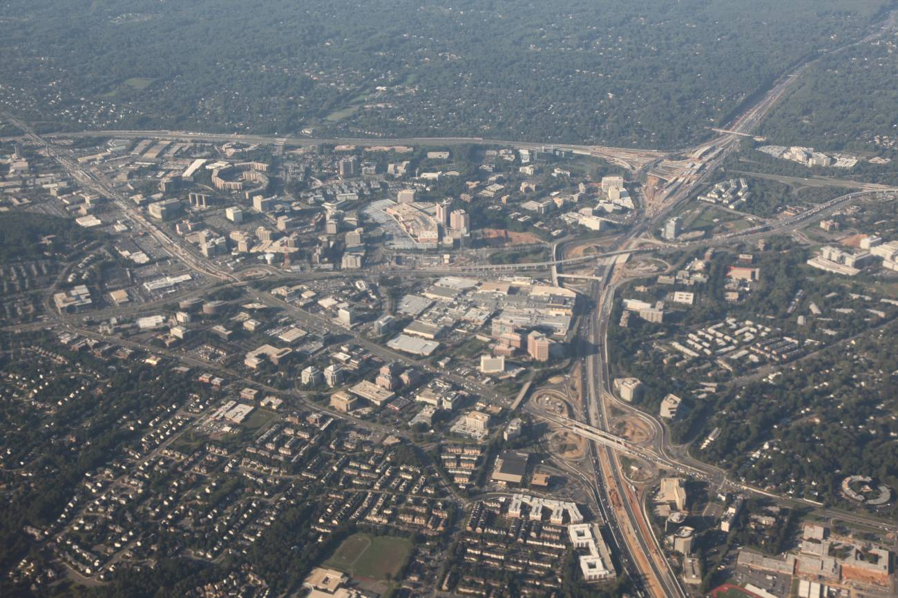
The Paradigmatic Edge City. Tyson’s Corner, Virginia, October 2011 (Elvin Wyly). Tyson’s Corner was just a small intersection with a general store and gas station in the 1930s, but now has more commercial space than downtown Miami. Its growth was driven in large part by Til Hazel, a lawyer who had specialized in litigation over the proposed locations for interchanges along the “beltway” highway that encircles Washington, DC. Hazel soon realized that this kind of expertise would be far more lucrative if he were a real estate investor and developer. Near the end of his career when asked about the disappearance of green space and controversies over the development of rural land, Hazel replied, “It’s a war. How else would you describe it?” See Dolores Hayden (2003). Building Suburbia. New York: Pantheon, p. 158.

Just as Wolfe’s Bonfire of the Vanities captured the sense of time and sense of place of New York in the 1980s, A Man in Full captures the essence of life, power, and profit in the fast-growing suburbs of Atlanta in the 1990s. All the elements are here: the racial segregation, the highways, and of course the figure of the charismatic entrepreneurial developer looking at it all from the window of the Gulfstream G-5 jet overhead. But this is very much a Canadian story as well. After being influenced by Garreau’s ideas that shopping centers were best understood as the village squares of the new edge cities emerging across North America, the Toronto-based Cambridge Shopping Centres purchased the old run-down Oshawa Center for $145 million in 1991. “ ‘So, taking that theory,’ said Ronald Charbon, Cambridge’s director of strategic market information,

“we said, ‘Where are the next edge cities going to occur? Where is the next wave of growth going to occur in the greater metropolitan Toronto area? And are any of our shopping centres sufficiently located to capitalize on that growth?’”

After a bold series of investments and efforts to recruit upscale retailers to the area,

“The Oshawa Centre is ... in the midst of a massive transformation from a jerry-built suburban mall into a mixed-use development that includes retail, business, government, and community services, all inspired by Garreau’s book.”

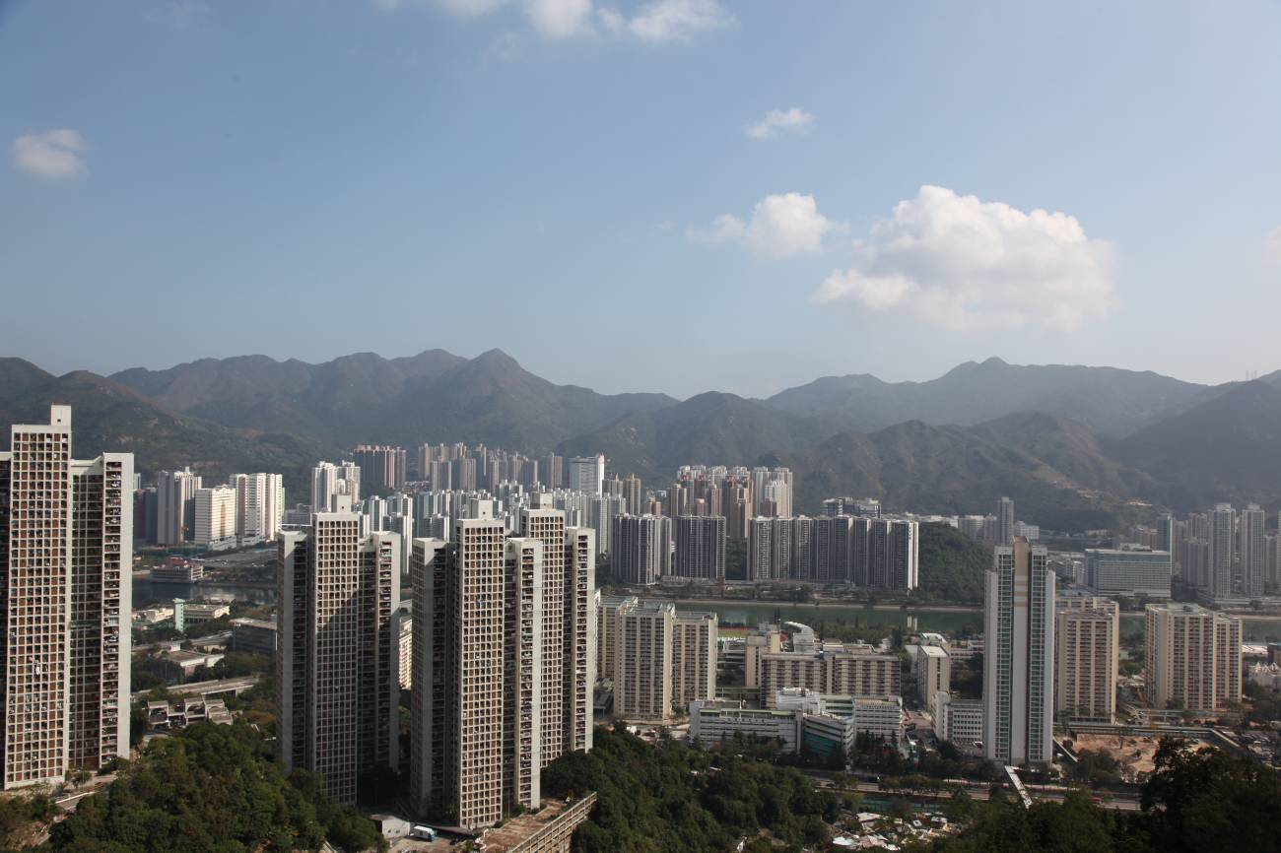
Contingencies of Global Suburbanism. Shatin New Territory, January 2010 (Elvin Wyly). “Suburbia” grew so rapidly in North America in the middle of the twentieth century that it distorted perceptions of suburbanisms that came before, and obscured distinctive suburban trajectories that have unfolded in other parts of the world. There certainly is a lot of evidence of Canadian and U.S.-style suburban growth on the outskirts of many cities around the world. But there are many important exceptions. Hong Kong illustrates the significance of the state in controlling and planning suburbanization. Beginning in 1973, the New Town Development Programme identified key sites in the New Territories north of Hong Kong Island, and coordinated public transit construction with public, non-market housing development. By 2006, the New Territories accounted for more than half of the entire Hong Kong region’s population of 6.7 million. See Si-ming Li (2009). Housing and Urban Development in Hong Kong: Political Economy and Space. Occasional Paper No. 94. Hong Kong: Center for China Urban and Regional Studies, Hong Kong Baptist University.

Edge cities, and discussion about edge cities, is now a truly transnational phenomena. Given the increased spatial mobility made possible by the automobile, urbanization spreads across the landscape rapidly in any society with sufficient wealth to support automobile ownership and all the associated needs (especially the construction of good highways). But as the phenomenon has expanded, so has the controversy. It has become increasingly difficult to encourage calm, measured discussion of suburbia in recent years for two inextricable reasons: First, suburbia is now equated with “sprawl.” Second, millions of people continue to choose to live in places that are described as suburban sprawl.

Macionis and Parrillo provide a concise definition on the first point:

“Sprawl is the term used to describe spread-out or low-density development beyond the edge of services and employment. It separates where people live from where they work, shop, and pursue leisure or an education, thereby requiring them to use cars to move between these zones. This type of development results from decades of unplanned, rapid growth and poor land-use management. Sprawl thus identifies the cumulative effects of development that is automobile-dependent, inefficient, and wasteful of natural resources.”

On the second point, Macionis and Parrillo observe:

“Sprawl is like that cartoon snowball rolling down the hill, growing in size and momentum, becoming practically unstoppable. In the past half-century, government policies on taxation, transportation and housing – nurtured by society’s embrace of laissez-faire development – subsidized virtually unlimited low-density development. And the more this development occurred, the more people clamored for it.”

Contemporary urban and regional planning is thus trapped in a painful dilemma. Planners learn quickly that unrestrained suburban sprawl has a variety of negative consequences, but if they try to stop it they encounter widespread and intense resistance and resentment: millions of people want the amenities and lifestyles that the phenomenon called ‘sprawl’ is able to deliver. On the other hand, if planners acquiesce to the preferences of the most politically engaged residents and development companies that shape suburban communities, their profession is quickly redefined and co-opted.

If the widespread popularity of the suburb means it can no longer be considered subordinate or subservient, however, there still may be other reasons to retain the word itself. The distinguished urban/suburban historian John Teaford writes that suburbs

“are not subordinate to the urb; but they are subversive to the whole concept of the urb, the commercial and cultural focus of an extensive hinterland, and thus perhaps are deserving of the title suburb after all. Their triumph marks the victory of the amorphous metropolitan mass over the focused metropolis of the past. They have supplanted the notion of the city as a center ... creating a new centerless world where ... the longstanding pull of downtown has diminished to a faint tug.”

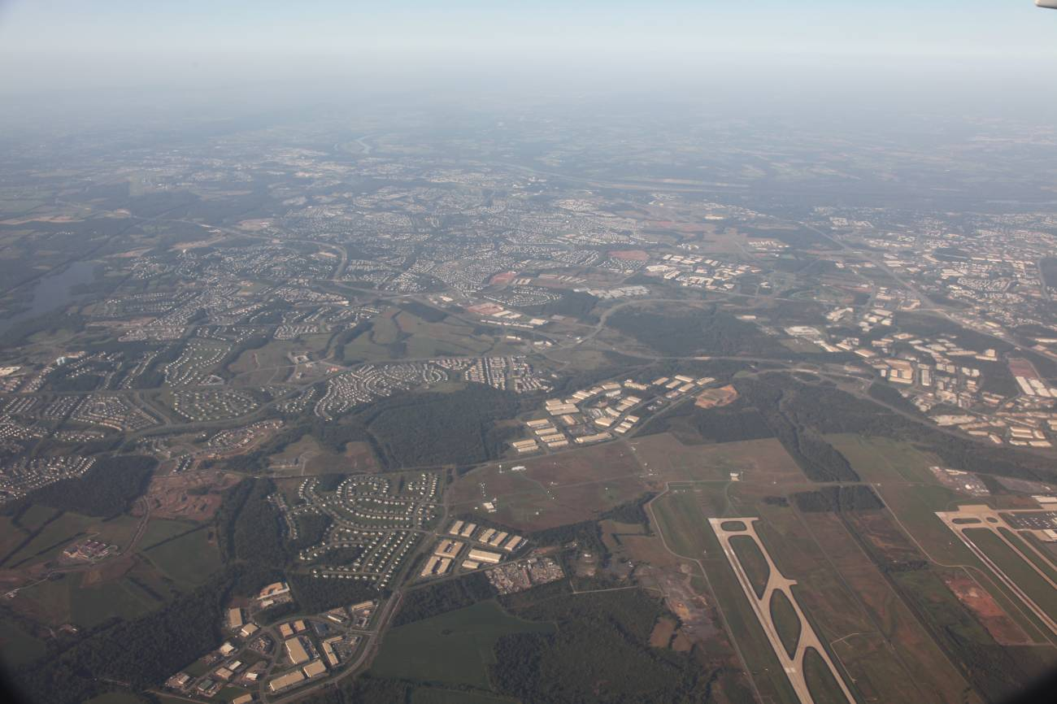
Neoliberal Frontier. Loudoun County, Virginia, October 2011 (Elvin Wyly). The view is to the north, with the runways of Dulles Airport at lower right. The patchwork of low-slung warehouses surrounding the airport are part of a special Foreign Trading Zone that was formally declared outside U.S. territory for the purposes of tariff laws and customs import regulations. When the U.S. invaded Iraq in 2003, the cell phones used by officials and contractors inside Baghdad’s “Green Zone” were assigned the area code for Northern Virginia. It is estimated that half of the world’s internet traffic runs through the many data centers in Loudoun County. In the first decade of the twenty-first century, Loudoun was repeatedly ranked as the wealthiest and fastest-growing county in the United States. In the 1990s residential development consumed more than 4 acres of open space each day. See Jamie Peck (2011). “Neoliberal Suburbanism: Frontier Space.” Urban Geography 32(6), 884-919.

The suburban world does indeed seem “centerless” in spatial terms, and the horizontal expansion of suburbia has gone so far that the urbanist Robert Lang suggests that “edge cities” have given way to “edgeless cities.” But being centerless, or on the edge in spatial terms need not imply a peripheral position in relation to political power. Contemporary suburbia, in fact, can involve greater power and authority than what we might find in the older central city. The extreme case might be Loudoun County, Virginia, a suburb just outside Washington, DC that “has become a low-density capital for the new economies generated by government outsourcing, Internet commercialization, speculative property development, and the security-industrial complex.” The political journalist Thomas Frank visited Loudoun, and asked, “Who are these people? ... Who lives in these houses, these estate homes, these gated reserves and Grand Rembrandts?” His explorations and interviews led him to answer that

“...it’s everyone who grabbed as the government handed off its essential responsibilities to the private sector over the past few decades, including weapons designers, ‘systems integrators,’ computer servicers, contract winners of every description, and, yes, the lobbyists who have greased the wheels. ... This Washington is the developers’ city, the lobbyists’ city, the defense contractors’ city: a capital undone and remade by Ronald Reagan and George W. Bush and a thousand wild-eyed deregulators.”

Suburban growth reflects the politics of the society that produces it, and in the United States those politics have been dominated by privatization, de-regulation, free markets, and intense real estate speculation. Jamie Peck suggests, therefore, that suburbia is “neoliberalism’s back yard.” Paul Knox goes even further, and argues that the landscapes of contemporary suburbia play a key role in reproducing material dreams and consumption fantasies:

“In a consumer economy driven by dreams and fantasies ... and polarized by free-enterprise neoliberalism, the commodified reinterpretation of utopian ideals has created distinctive landscapes. These landscapes are not only emblematic of the materialism of U.S. consumer culture but also both a product and cause of it. The landscapes of upscale suburban America are, more than anything else, ostentatious and meretricious. Infused with the bigness and bling endorsed by developers’ focus groups, the private master-planned developments at the leading edges of the New Metropolis amount to what I have called schlock and-awe-urbanism.”

Commodified Community

The struggle to understand spatially expansive communities -- burgeoning suburbs that seem too hard to get our minds around while walking or even driving through them -- is not the exclusive domain of urbanists and social scientists. As it turns out, the art and science of marketing have become critically important practices in attempts to measure community; and their measures are now routinely used by scholars trying to understand urban and regional patterns and processes. Direct-mail marketing, and subsequently telemarketing and even certain variants of Internet-driven e-commerce, are certainly not limited to suburbs. But it is usually in the suburbs where marketing considerations have played a crucial role early on, in many cases from the first stages of a developer’s estimation of market demand when crafting a new subdivision. At least for the last forty years, suburbanization has been accelerating in synch with the accelerated emphasis on privatization, free markets, and corporate control.

Census data, collected for years in Canada, the United States, and many other industrialized countries, has always justified its expense through commercial applications. But the commercialization of these data accelerated in the 1960s with the introduction of a new numbering system for mailing addresses in the United States, referred to as the “Zone Improvement Plan,” which created a national system of ZIP codes. By the mid-1990s there were more than 36,000 ZIP codes in the U.S. Designed to provide efficiency for large companies sending out lots of mail (the codes could be easily sorted on newly-developed optical character recognition systems), these codes soon became the spatial link to any kind of consumer information that would help a marketer reach a ‘target audience’ faster, more accurately, and with reduced cost. If automated mailing lists could be generated for zip codes, then it became increasingly important to describe these zones with as many kinds of information as possible; Census data were used to characterize zip codes, but many companies conducted surveys of consumers, or examined sales and inventory trends in retail stores, in sampled zip codes to get more customized data. The next step is to use statistical procedures to group the large number of zip codes into a few “clusters” that identify groups with common demographic, economic, and consumption profiles. This “geodemographic marketing” industry has become a large and lucrative business over the past generation.
Suburbanization made metropolitan areas so large and expansive that it became difficult for companies to understand local patterns using standard statistics provided by government agencies. Thus a large “geodemographic marketing” industry emerged to help companies and institutions target people and places in the dispersed metropolis.

In Canada, the market leader is a firm named Environics, which has produced a rich dataset that inspired a full, two-page in the Vancouver Sun, under the banner headline, “Which Tribe do You Belong To?”

“Who are we?

As it turns out, we are our neighbourhoods.

It’s easy to be deceived by our apparent sameness, the endless repeating sequence of Starbucks and Subways and Superstores, set amid the region’s quickly cloning megahouses, townhouse clusters, and towers.

But look more closely and Vancouver turns into a collection of Balkan villages, each with its own language and customs and traditional costumes.”

The article goes on to provide a detailed local interpretation of “66 tribes in Canada that have been identified in the most comprehensive national system yet developed for naming all those cultures” by Environics, which built a database that “incorporated everything from Canadian census data to Environics’ social-values surveys to information about car-buying patterns to put us into clusters with names ranging from Urbane Villagers to New Homesteaders to Park Bench Seniors.”

Suburban Environmental Determinism?

Critics of suburban community rightly emphasize the spatial dispersion -- and spatial mobility -- associated with contemporary life in most North American urban regions. Yet the critics of suburbia often succumb to a very determinist logic, assuming, for instance, that we can draw a direct link between particular social problems and the spatial form of the city in which we find these problems. For many years, this “environmental determinism” has been used as a convenient shorthand explanation for the problems found in poor communities. Generations of social scientists have studied the landscapes found in poor communities -- the landscapes and building types in inner-city high-rise housing projects, or peripheral squatter settlements in cities of the Global South, or suburban housing estates around European cities -- in search of factors in the living environment that explain the failure to achieve upward mobility, or the persistence of self-destructive behaviors. In recent years, this approach has also been applied more frequently to explain the feelings of isolation and disconnection in White, middle-class suburbs in Canada and the United States. In his film Bowling for Columbine, for instance, Michael Moore spends a lot of time exploring the suburbs north of Denver, Colorado, asking people why two teenagers shot people to death at their high school; Moore’s attacks on the suburban way of life are mostly indirect and implicit, but they are unmistakable.

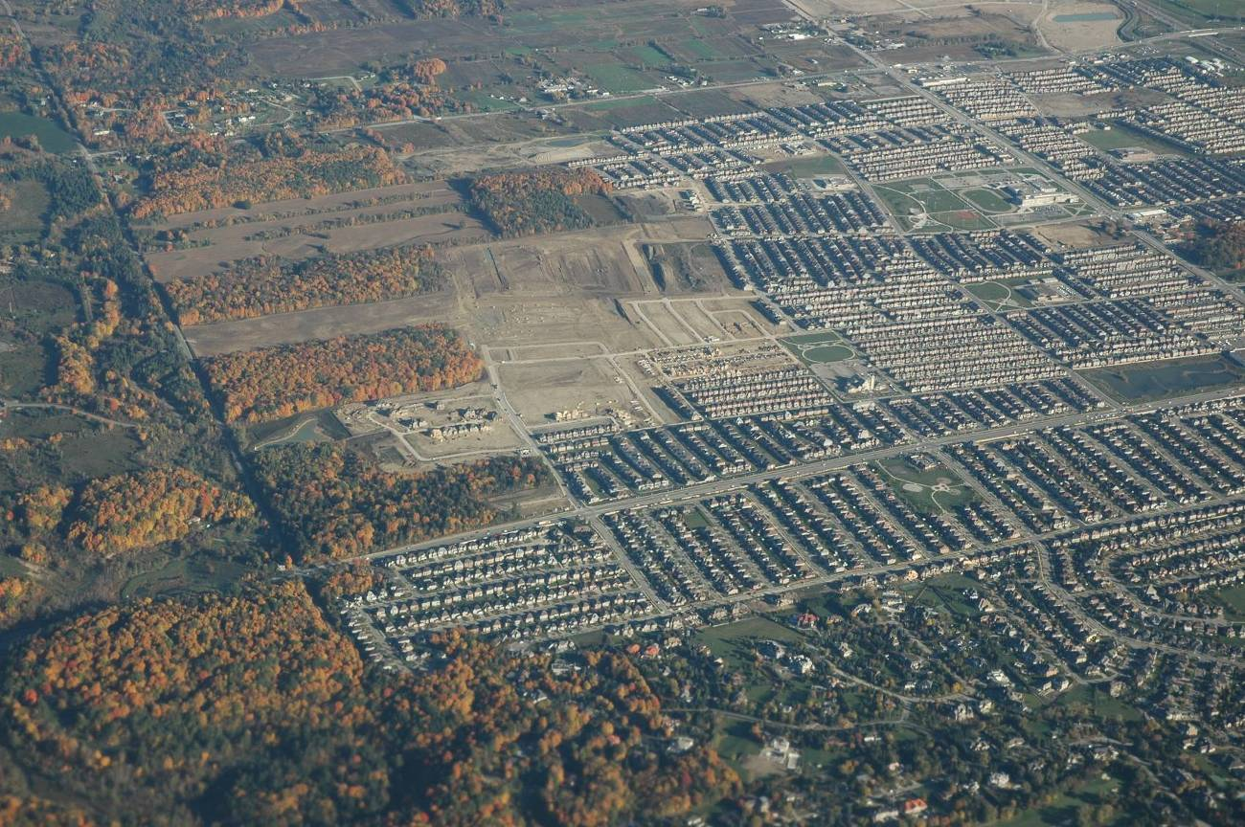
Community on the Edge? Southern Ontario, north-west of Toronto, October 2005 (Elvin Wyly).

Environmental determinism is now seen as a very risky kind of reasoning -- a simplified approach that often slips into unfair stereotypes about people and places. But automobile-oriented landscapes do have some serious problems, and so it is worth considering the way that these machines seem to determine certain aspects of social life in the suburbs.

The paralyzing traffic congestion of many suburban regions attests to the fact that a technology we initially devised to conquer spatial distance has become a powerful conditioning force itself. Mumford could see this contradiction half a century ago. “All that is left of the original impulse toward autonomy and initiative” in the escape from the industrial city to the new greenfield suburbia,

“is the driving of the private motor car; but this itself is a compulsory and inescapable condition of suburban existence. ... The current cost of this ‘freedom’ in the United States -- 40,000 dead and more than a million people injured or maimed for life every year -- must be partly debited from the favorable side of the suburban movement.”

Today,

“The love of automobiles, which once reached fever pitch in California, has cooled as traffic has become vexing. Nobody records popular songs anymore about the pleasures of ‘little deuce coupes’ and ‘little GTOs,’ as they did with outstanding success in the 1960s.”

The average licensed driver in the United States now drives thirty-two miles a day, and much of this traffic has been funneled onto large highways and arterial roads, which have turned out to be rather unpleasant places to spend time. There are many problems with automobile-oriented landscapes; but from the perspective of a sense of community, we can identify seven main issues.

First, “there is an irritatingly large number of vehicles struggling for space” on congested road corridors.

Second, drivers usually have no alternatives in their route, a problem that is painfully clear in the case of accidents or traffic jams.

Third, big-road intersections involve terribly long waits at traffic lights, imposing ever-worsening delays for motorists who see cars moving in the distance but often must wait through two or three cycles to get through the light.

Fourth, the suburban road hierarchy, with its small cul-de-sacs leading to slightly larger feeder roads, to minor arterials, to major arterials, to the limited-access freeway, is an astonishingly confusing and difficult landscape to navigate. Compared with the medieval town protecting itself with walls and fortified defenses, the contemporary North American suburb often needs no protection from outsiders, who quickly get lost in the road network.

Fifth, the big-road environment forces businesses to adapt to traffic in their efforts to communicate with and attract consumers.

“Travelers are stuck viewing highway pavement and businesses that have established themselves along the arterials. This particular business environment, the commercial strip, was designed ... to attract customers who might be driving past at fifty miles an hour. So it is by nature a place of simplified, pared-down communication. [One prominent researcher] compares the roadside business environment to a newspaper headline; it imparts basic information about the businesses, and that’s all. Yet the poor suburbanite is forced by the street and road hierarchy to use the same route over and over, so he or she sees this same simple, newspaper-headline-style environment hundreds of times a year. It dulls the senses.”
Sixth, the lengthy and congested commute becomes a central part of daily and weekly life, becoming an anchor on many aspects of family life. Any separation between home and work – whether it happens for residents of dense city neighborhoods or distant edge-cities – will place some limits on the schedule and behavior of workers, their friends, and their families. But many distant suburbs were built specifically on the assumption of quick, easy movement between distant spaces in the suburbs. As things become more congested, land prices near major edge cities rise, and so people are forced to trade off being close by or moving still farther out and enduring ever longer trips. On average, Los Angeles drivers wasted 93 hours per person in traffic, solely as a result of delays – not counting the many hours spent actually moving at the expected speed to get from one point to another. This is almost four days a year spent watching the bumper of the car in front of you. Even if congestion is not a problem, the long commutes often required in suburbia become a major part of life: if you work an average full-time schedule for a year, and you spend half an hour commuting each way, then you’re spending more than ten days every year shuttling between home and work. But some folks spend far more time than that. In 2006, the Midas muffler company celebrated its fiftieth anniversary, and decided to give an award for America’s longest commute; the winner was an engineer at Cisco Systems, who spends seven hours every day traveling from his home in California’s Sierra foothills to the Cisco office in San Jose. The case of the Midas award-winner hints at some fascinating aspects of the daily commute in contemporary suburban society:
Seven consequences of the auto-dependent suburb:

1. Worsening congestion.
2. Narrowed alternatives in travel routes.
3. Lengthening delays at major intersections.
4. The suburban road hierarchy creates a confusing landscape.
5. The fast-moving environment fosters business communication that “dulls the senses.”
6. The long commute becomes a central part of daily life.
7. The automobile itself becomes a space for social life.

“People like to compare commutes, to complain or boast about their own and, depending on whether their pride derives from misery or efficiency, to exaggerate the length or brevity of their trip. People who feel they have smooth, manageable commutes tend to evangelize. Those who hate the commute think of it as a core affliction, like a chronic illness. Once you raise the subject, the testimonies pour out, and, if your ears are tuned to it, you begin overhearing commute talk everywhere: mode of transport, time spent on train/interstate/treadmill/homework help, crossword-puzzle aptitude – limitless variations on a stock tale. People who are normally circumspect may, when describing their commutes, be unexpectedly candid in divulging the intimate details of their lives. They have it all worked out, down to the number of minutes it takes them to shave or get stuck at a particular light. But commuting is like sex or sleep: everyone lies. It is said that doctors, when they ask you how much you drink, will take the answer and double it. When a commuter says, “It’s an hour, door-to-door,” tack on twenty minutes.”

The U.S. Census Bureau now estimates that there are more than 3.5 million “extreme commuters” – people who spend at least ninety minutes each way in the work journey. This is almost twice the number as in 1990.

“They’re the fastest-growing category, the vanguard in a land of stagnant wages, low interest rates, and ever-radiating sprawl. They’re the talk-radio listeners, billboard-glimpsers, gas guzzlers, and swing voters, and they don’t – can’t – watch the evening news. Some take on long commutes by choice, and some out of necessity, although the difference between one and the other can be hard to discern. A commute is a distillation of a life’s main ingredients, a product of fundamental values and choices. And time is the vital currency: how much of it you spend – and how you spend it – reveals a great deal about how much you think it is worth.”

This brings us to the seventh main problem for community in auto-dependent urban environments: the automobile becomes the setting for a significant part of social life. When the commute becomes the binding constraint on individual and family schedules, and when the commute requires spending more and more time in an automobile, people necessarily adjust. Sometimes these adjustments require difficult choices. Stephen Kocis, who lives on the southern fringe of Atlanta, lives in “a planned community of well-heeled developments connected by golf cart paths” about fifty miles from his workplace.

“Though Kocis is normally a fitness freak, with a black belt in karate, in the past year he’d put on twenty pounds and developed nerve problems in his back” from the long drives. “For a while, he tried leaving at five, to get to the office at sixt-thirty, in time to work out, but it exhausted him. So he gave up exercise. ‘I don’t have a social life,’” he said. “He and his wife, Martha, get a babysitter once a month or so and go out for dinner in Peachtree City; they hardly ever go into Atlanta. Generally, he comes home, helps his two songs with their homework, puts them to bed, works a little bit, then watches ‘Grey’s Anatomy’ or ‘Desperate Housewives’ on TV. ‘My wife enjoys it, but God I hope she doesn’t relate to it.’”

Stephen Kocis’s experience may be extreme, but urban planners have been increasingly concerned about the consequences of automobile landscapes for daily physical activity. In the first comprehensive study of this issue in Canada, however, overall levels of physical activity were surprisingly similar between high-density and low-density residential environments. What varies most are the types of activities:

“Residents of urban areas are more likely to get around actively, i.e., by walking or cycling, while tending to their daily affairs. On the other hand, residents of suburbs are much more apt to get their exercise by performing outside work (gardening, yard work and cleaning).”

For Stephen Kocis, the long daily commute seems to have destroyed the possibilities for a healthy social life: there’s just not enough hours in the day. For millions of other suburbanites, however, the commute has begun to create a sort of social life itself, inside the moving vehicle. For some commuters, “One remedy for social isolation and frequent tire replacement is the van pool.” But for others it’s the cellphone, or talk radio, either on the AM dial or one of the hundreds of stations now available on (comparatively) inexpensive satellite radio systems you can stick on the dashboard. And we should not underestimate the power of the sense of social connection that people can build when they listen to the same voice on a regular basis over long periods of time. Many love him, many hate him, but nobody can dispute his influence over millions of Americans; this statement applies to the conservative talk-radio host Rush Limbaugh, and it also applies to the raunchy drive-time morning routines done by Howard Stern, who for many years pushed every single boundary of taste with sexist and often racist jokes and comedy routines that attracted numerous fines and allegations of over-the-air decency. But it attracted millions of listeners, too. “Look, my life isn’t about the First Amendment,” Stern told an interviewer in the late 1990s when asked about the regulatory crackdowns on his morning show.

“‘My life is sincerely about envisioning a guy driving to work in his car and making him laugh.’ That is Stern’s discovery: that the mass version of the great American night club, the rec room, the psychiatric couch is an air-conditioned seat smack in the middle of a traffic jam, and the voice in the car seems like an outlaw but is mainstream. It is a discovery worth millions.”

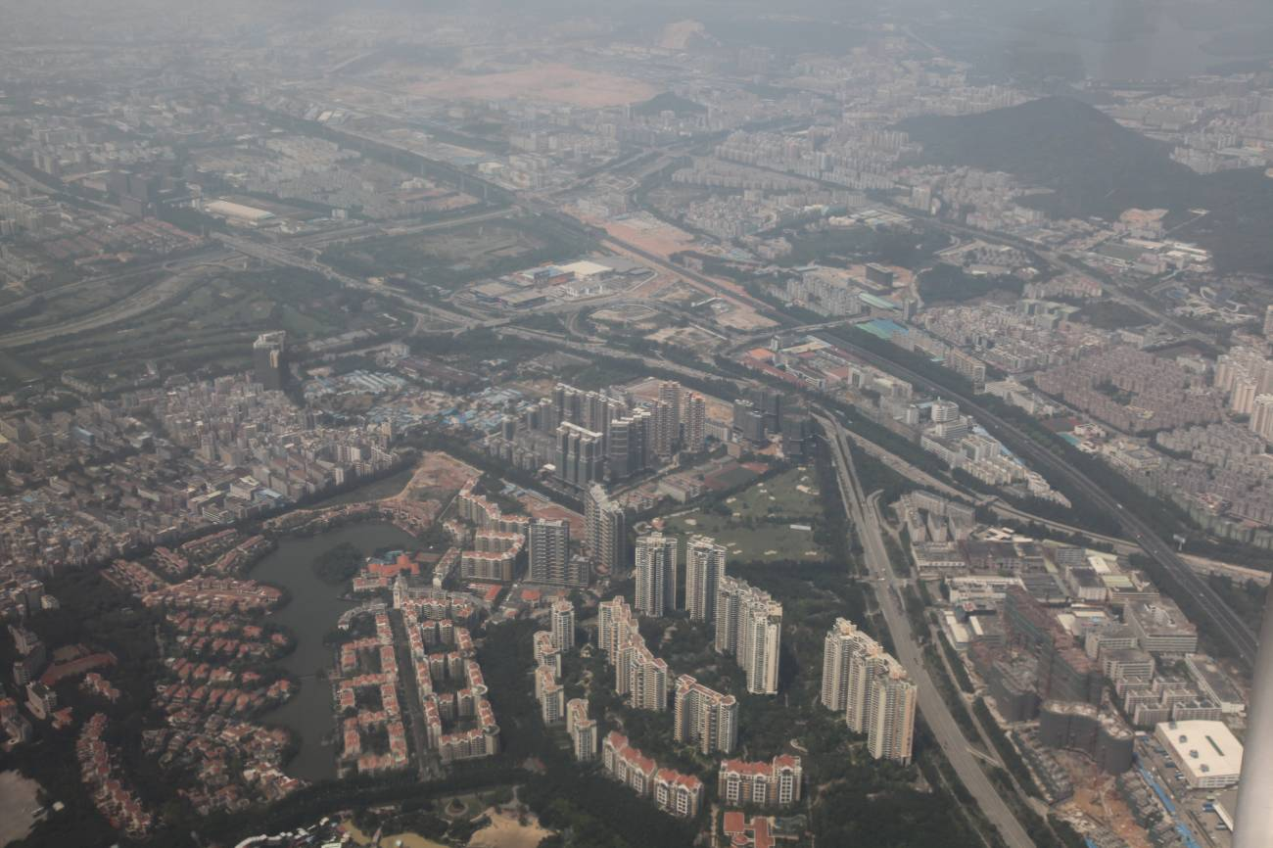
Suburbanization in Shenzhen, China, February 2010 (Elvin Wyly). Compared to the North American experience, suburbanization in contemporary China involves much stronger control by centralized political authority, but also much more localized, informal initiatives by small communities. Planning for high residential densities and efficient public transportation is also sharply different from the North American path. Shenzhen was declared a special economic zone in the late 1970s, and thus exploded from a patchwork of small rural settlements into a metropolis of more than 14 million people. Even so, much of the suburban growth has involved “former rural collectives encircled by a city,” creating urban villages (chenzhongcun) that form “an internal other that is both the antithesis and the condition of possibility” for the giant metropolis itself. Jonathan Bach (2010). “They Come in Peasants and Leave Citizens: Urban Villages and the Making of Shenzhen, China.” Cultural Anthropology 25(3), 421-458.

Social Networks in Suburbia

And yet many of us know suburbanites who are willing to endure the long commutes in order to find an affordable home away from the city, with lots of open space. And people can be quite creative in how they adapt to the constraints of traffic, driving, and the relations between home and work in low-density suburbs. And it is also undisputable that community and connection endures, in the face of all the attacks by social scientists, city advocates, cultural critics, and everyone else. Why?

A new stream of influential work that bridges economics, geography, and sociology -- often dubbed a subfield of “economic sociology” -- offers one compelling set of explanations. Network theory is a new attempt to integrate the classical sociological theories of community with new insights on the spatial organization of social life. This framework portrays all people as enmeshed in complex “webs of group affiliations.” But not all of these affiliations are the same, and not all parts of the web have the same strength: recall Wirth’s reminders of how we have many relations with people that just involve a few limited kinds of interaction. The economic sociologists have built on this work to understand the differences between “strong” ties (between people and their families, close friends, and the like), and “weak” ties (casual friends, distant co-workers, acquaintances, etc.). Some of the most important findings of economic sociology involve the strength of weak ties: evidence that people often get a lot of information and support from diffuse webs of ties, each of them individually weak, but collectively very strong. The strength of weak ties has changed the way people understand labor markets, for example: although some people find out about job opportunities from strong ties (their very close friends or relatives), many more get this kind of information from their larger network of weak ties.

These affiliations, strong ties and weak ties, have been re-spatialized -- spread out across the expanding metropolis -- thanks to the advances of transportation and communications technologies. Social networks have become much more spatially dynamic, and thus very hard to categorize, classify, and measure. As applied in the suburbs, network theory sheds light on the ubiquitous webs of support and communication that almost all residents have -- regardless of where they live. Sociological research has also demonstrated that central-city, suburban, and rural residents have very few systematic differences in the number of social ties they have; “However, the kind of involvement differs: People in small towns and nonmetropolitan areas are more involved with kinfolk; urbanites and suburbanites are more involved with non-kin friends.” Close ties tend to share important social, demographic, economic, and often cultural or political sensibilities; in this way, the level of class or racial homogeneity in a suburb will play a role in the likelihood that people’s strong ties will tend to be locally-oriented. But weak ties also matter, and in some cases ‘single-stranded ties’ can be quite important as well:
Social networks are re-spatialized in suburbia, spread out across space by advances in transportation and communications technology. Suburban community is more spatially complex and dynamic compared to small towns or city neighborhoods, but it is still community. The vast majority of new urban growth -- and thus new community -- is happening in suburbia.

“For fifteen years, a group of commuters took the 7:27 AM train into Chicago and the 6:02 PM back to suburban Whiting, Indiana, on Monday through Friday. This group hosted retirement parties for ‘members’ on the train, celebrated the end of the workweek together, and carried on running conversations about their lives, all -- and only -- on the train.”

All of these social ties are spatially dispersed, frequently and in some cases continuously in motion, and therefore easy for outsiders to ignore, dismiss, or misunderstand. In the end, community and connection in suburbia may appear quite different from anything described in the ‘urbanism as a way of life’ that Wirth penned from the context of the south side neighborhoods near the University of Chicago so many years ago. But the fundamental tension of community -- the relations between the individual and society, personal autonomy and intimate social bonds -- may not be so different after all in city and suburban neighborhoods.



Washington, DC, seen across the Potomac River from the Northern Virginia suburbs, October 2011 (Elvin Wyly).

Jacob Cohen, who in his fifties achieved comedic fame for the self-deprecating line, “I don’t get no respect,” was born in Babylon, New York, on Long Island, in 1921. Mel Watkins (2004). “Rodney Dangerfield, Comic Seeking Respect, Dies at 82.” The New York Times, October 6, A29.
Lewis Mumford (1961). The City in History. New York: Harcourt, Brace, and World, 487.
William H. Whyte, Jr. (1956). The Organization Man. New York: Doubleday, 310.
Whyte, Organization Man, 330.
John Keats (1956). The Crack in the Picture Window. Boston: Houghton Mifflin, 61, quoted in Phillips, City Lights, 168.
Quoted in Kenneth T. Jackson (1985). Crabgrass Frontier: The Suburbanization of the United States. New York: Oxford University Press, 231.
Richard Harris (2004). Creeping Conformity: How Canada Became Suburban, 1900-1950. Toronto: University of Toronto Press, 6.
E. Barbara Phillips (2010). City Lights: Urban-Suburban Life in the Global Society, Third Edition. New York: Oxford University Press, 221.
A quick glance at Jackson’s chapter titles conveys the complexity and contingency of the trajectory: suburbs as slums; the transportation revolution and the erosion of the walking city; home sweet home: the house and the yard; romantic suburbs; the Main Line: elite suburbs and commuter railroads; the time of the trolley; affordable homes for the common man; suburbs into neighborhoods: the rise and fall of municipal annexation; the new age of automobility; suburban development between the wars; federal subsidy and the suburban dream: how Washington changed the American housing market; the cost of good intentions: the ghettoization of public housing in the united states; the baby boom and the age of the subdivision; the drive-in culture of contemporary America; and the loss of community in metropolitan America. Jackson, Crabgrass Frontier, xi.
Herbert J. Gans (1967). The Levittowners: Ways of Life and Politics in a New Suburban Community. New York: Pantheon, v.
Gans, The Levittowners, 409.
James Howard Kunstler (1994). The Geography of Nowhere. New York: Simon & Schuster. The “places not worth caring about” quote comes from James Howard Kunstler (2007). The Tragedy of Suburbia. Long Beach, CA: TED Conference, May 2007.
Joel Garreau (1991). Edge City: Life on the New Frontier. New York: Doubleday.
Tom Wolfe (1998). A Man in Full. New York: Farrar, Strauss, and Giroux. Excerpted in John J. Macionis and Vincent N. Parrillo (2007). Cities and Urban Life, Fourth Edition. Upper Saddle River, NJ: Pearson-Prentice Hall, p. 105.
David Berman (1997). “Shopping on the Edge.” Canadian Business, October 31, 72-79, cited in Macionis and Parrillo, Cities and Urban Life, p. 111.
Macionis and Parrillo, Cities and Urban Life, p. 111.
John J. Macionis and Vincent N. Parrillo (2007). Cities and Urban Life, Fourth Edition. Upper Saddle River, NJ: Pearson-Prentice Hall, p. 93.
Macionis and Parrillo, Cities and Urban Life, p. 95.
John Teaford (2008). The American Suburb: The Basics. New York: Routledge, p. xii; cited in Jamie Peck (2011). “Neoliberal Suburbanism: Frontier Space.” Urban Geography 32(6), 884-919.
Robert Lang (2003). Edgeless Cities: Exploring the Elusive Metropolis. Washington, DC: Brookings Institution Press.
Jamie Peck (2011). “Neoliberal Suburbanism: Frontier Space.” Urban Geography 32(6), 884-919, quote from p. 890.
Thomas Frank (2008). The Wrecking Crew: How Conservatives Rule. New York: Henry Holt, quotes from pp. 21, 22, 24, cited in Peck, “Neoliberal,” p. 890.
Peck, “Neoliberal,” p. 892.
Paul Knox (2008). Metroburbia, USA. New Brunswick, NJ: Rutgers University Press, p. 156.
Frances Bula (2005). “Which Tribe do You Belong To?” The Vancouver Sun, April 29, A8-A9, quote from p. A8.
Bula, “Which Tribe?” p. A8. The obsession with classifying and categorizing has been widely criticized, and also makes for some good satire. See the Onion News Network’s take on the 430 demographics that candidates for the U.S. 2008 Presidential election need to reach.
Mumford, City in History, p. 492-493.
Philip Langdon (1994), A Better Place to Live: Reshaping the American Suburb. Amherst: University of Massachusetts Press, p. 34.
The first five of these come from Langdon, A Better Place to Live, pp. 34-36.
Langdon, A Better Place, pp. 35-36.
Cited in Macionis and Parrillo, Cities and Urban Life, p. 100.
Nick Paumgarten (2007). There and Back Again. The New Yorker, April 16, 58-70, quote from p. 58.
Paumgarten, “There and Back Again,” p. 58.
Paumgarten, “There and Back Again,” p. 68.
Martin Turcotte (2009). Are Suburban Residents Really Less Active? Catalogue No. 11-008. Ottawa: Statistics Canada.
Paumgarten, “There and Back Again,” p. 68.
David Remnick (1997). “The Accidental Anarchist.” The New Yorker, March 10, 56-67, quote from p. 67.
Phillips, City Lights, p. 189.
Phillips, City Lights, p. 190.

